Chapter VIII

The Strings Class and Magpie Lab

Chapter VIII Topics

8.1 Introduction to String Methods
8.2 Constructing String Objects
8.3 String Method length
8.4 Working with Substrings
8.5 Converting Strings
8.6 Comparing Strings
8.7 Altering Strings
8.8 Adding Methods to the Utility Library
8.9 Introduction to the Magpie AP® Lab
8.10 Initial Chatbot Response
8.11 Chatbot Adds Random Responses
8.12 Improving the Negative Response
8.13 Summary

8.1 Introduction

Strings are a set of characters in every conceivable arrangement and size. Strings are everywhere, both inside and outside the computer world. A sentence is a group of characters. A page is a group of sentences. A book is a set of pages. A library is a set of books. Given enough computer memory, an entire library can be stored in a computer. Word processing term papers, writing memoirs, sending email messages, responding to surveys, placing online orders and registering products all involve string processing. Every software package on the market includes string-processing components. Every programming language has special features that facilitate the manipulation of strings, and Java is no different. Finally, let us not forget that every computer lab assignment program you write is one big collection of strings that work together, hopefully, to generate some desired and logical output.

You have actually been using the String data type for quite some time and to a large degree you may think that it was a simple or primitive data type. This is not surprising. Consider the variable declarations in figure 8.1.

Figure 8.1
int number;
char letter;
double gpa;
boolean finished;
String title;

You see five declarations and each declaration starts with a data type followed by a variable identifier. It appears that all five of the declarations behave in the same way. You may note one peculiar difference; the String declaration is the only data type that starts with an upper-case letter. Now look at the value assignments for each one of the variables in figure 8.2.

Figure 8.2
number = 2500;
letter = 'A';
gpa = 3.785;
finished = true;
title = "Exposure Java";

The assignment statement seems to give secondary evidence that String belongs with the simple data types. There appears lots of evidence that the String data type is a very convenient and lovely simple data type. It is true that a string stores multiple characters, but after all you have treated a string like a single unit. he true nature of strings has intentionally been hidden.During the early chapters you have benefited very nicely by treating and using strings as if they were no different from the other simple data types.

Well you are just thrilled to hear this, but you have a fundamental question. For six chapters, several months, and a fair number of lab assignments, you have survived so nicely treating String as a simple data type. What benefit is there now in revealing and treating String like a class? This is a profound question and the answer is quite simple. The String class has many methods that facilitate string manipulations.

In this chapter you take a new and fresh look at strings and you will see that there are many powerful methods that will simplify your life with any type of string business. The number of available String methods greatly exceeds what will be presented in this chapter, but you will learn the more common String methods. First, what exactly is a string?

String Definition
A string is a collection of characters.

The characters in a string include upper-case and lower-case letters, numerical characters and a large set of characters for a variety of purposes like:

! @ # $ % ^ & * ( ) _ +

String Literal Definition
A string literal is a set of characters delimited with double quotations like:

"Seymour Snodgrass" and "SSN: 123-45-6789"

8.2 Constructing String Objects

The biggest reason why you may not have suspected that String is a class, might be due to the fact that the new operator has been absent from our previous String programs. You know enough about classes and objects to realize that the construction, or instantiation of an object, requires the use of the new operator. The new operator is quite busy and allocates memory for the new object along with calling the appropriate constructor. String objects seem to work fine without using new.

Program Java0801.java, in figure 8.3, creates four String objects that all ultimately store and display the character string "Tango". You will see that some declarations use new and other declarations manage to create String objects quite easily without any assistance from the new operator.

Figure 8.3
// Java0801.java
// This program demonstrates multiple ways to construct String objects.
// Note that all four string objects store the same information.
public class Java0801
{
public static void main (String[ ] args)
{
String s1 = "Tango";
System.out.println("s1: " + s1);
String s2 = new String();
s2 = "Tango";
System.out.println("s2: " + s2);
String s3 = new String("Tango");
System.out.println("s3: " + s3);
String s4 = new String(s3);
System.out.println("s4: " + s4);
}
}

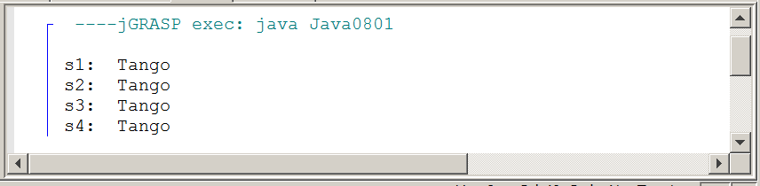
Program Java0801.java creates four String objects that all ultimately store the same value "Tango". You will see that the first String, s1, is created in the same manner that you learned back in Chapter 3. The other 3 String objects, s2, s3 and s4 are created in a very different manner. s2 shows that the String class has a default constructor. This default constructor will construct an empty string. s3 and s4 show two overloaded constructors being used. This overloaded constructor requires a String parameter to initialize the new String object. It does not matter if the parameter is a string variable, as with s4, or a string literal, as with s3.

8.3 String Method length

The first String method is length, which returns the numbers of characters in a string. Program Java0802.java, in figure 8.4, demonstrates length with three different objects. In particular, look at s3 and see if the space is counted as a character.

Figure 8.4
// Java0802.java
// This program demonstrates the use of the <length> method.
// It also reviews string concatenation with the < + > operator.
public class Java0802
{
public static void main (String[ ] args)
{
String s1 = "Argentine";
String s2 = "Tango";
String s3 = s1 + " " + s2;
System.out.println(s1 + " has " + s1.length() + " characters.");
System.out.println(s2 + " has " + s2.length() + " characters.");
System.out.println(s3 + " has " + s3.length() + " characters.");
}
}

Figure 8.4 Continued
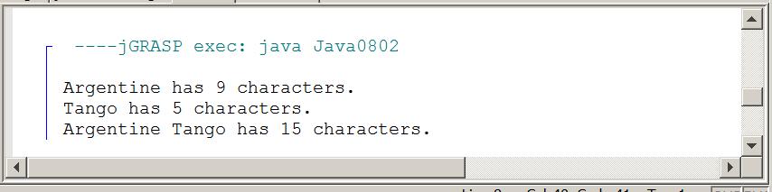

The output of Java0802.java proves that a space is indeed counted as a character. Invisible characters are called white space characters, but they are characters nevertheless and need to be considered with string processing.

String method length
int count = str.length();

Method length returns the length or number of characters in the String object.

If str equals "Aardvark" then count becomes 8.

8.4 Working with Substrings

Now that we can determine the number of characters in a string with length, we are ready to access individual characters. It is possible to construct substrings of larger strings by traversing a string and accessing a specified range of characters. Please note that it is substring and not subString, which is what I would have expected following the lower/upper case convention of most Java method names.

The first Java substring method uses two parameters: one parameter to indicate the index of the substring start and a second parameter to indicate the end of the substring. Do not think that second parameter is the index of the last character.

Program Java0803.java, in figure 8.5, shows several substring examples with the same original string. There are six substring commands. Each command has different integer parameters, and therefor displays a different part of the original string. Pay close attention to the two parameters and the actual substring that is retrieved for each of the six commands.

Figure 8.5
// Java0803.java
// This program demonstrates how to access specified characters of
// a string with the <substring(P,Q)> method, where P is the Start-Index and
// Q is one greater than the End-Index.
public class Java0803
{
public static void main (String[ ] args)
{
String s = "Racecar";
System.out.println(s.substring(0,4));
System.out.println(s.substring(1,4));
System.out.println(s.substring(2,4));
System.out.println(s.substring(2,6));
System.out.println(s.substring(3,6));
System.out.println(s.substring(4,7));
}
}

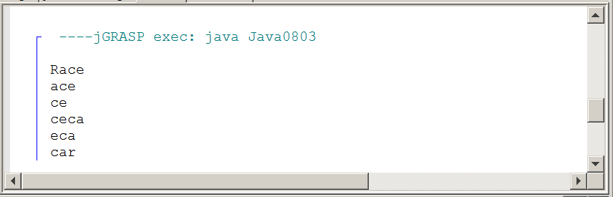

String method substring with 2 parameters
String s1 = "aardvark";
String s2 = s1.substring(j,k);

Method substring returns a set of consecutive characters from string s1, starting at index j, and ending at index k-1.

String s3 = s1.substring(4,7);

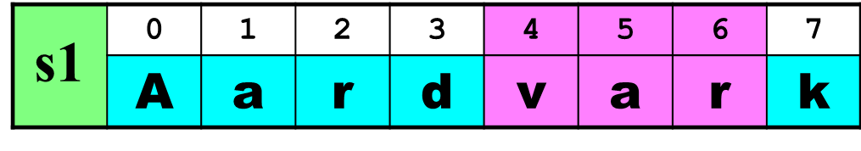
s3 becomes "var"

NOTE: The first index of a String is always 0.

Java has a second substring method with a single parameter. This parameter indicates the starting index used to build the substring. This second substring always goes to the end of the string. Program Java0804.java, in figure 8.6, has two loops using the same "Racecar" string. The first loop uses substring with a single parameter to the end of the string. The second loop creates the same results with the two-parameter substring method. The second parameter is fixed at the length of the source string. If you realize that the length of a string is one count higher than the final index then you see that the second substring method really has the same logic as the first substring method. It is almost like there is an invisible second parameter that is fixed at the length of the string.

Figure 8.6
// Java0804.java
// This program compares the two <substring> methods.
// Java can tell the difference, because of the different
// parameter signatures.
public class Java0804
{
public static void main (String[ ] args)
{
String s = "Racecar";
int n = s.length();
for (int k = 0; k < n; k++)
System.out.println(s.substring(k));
System.out.println();
for (int k = 0; k < n; k++)
System.out.println(s.substring(k,n));
}
}

Figure 8.6 Continued
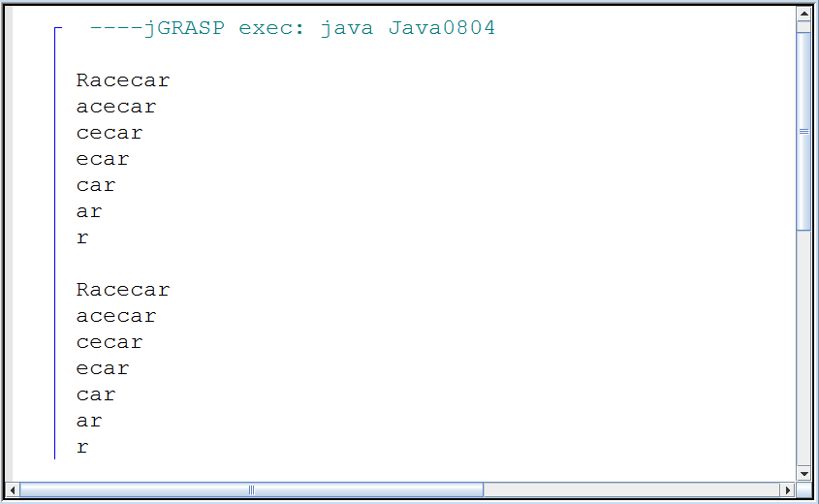

String method substring with 1 parameter
(substring is overloaded)
String s1 = “Aardvark”;
String s2 = s1.substring(j);

Method substring returns a set of consecutive characters from String s1, starting at index j, and continuing all the way to the end of the string.

String s3 = s1.substring(4);

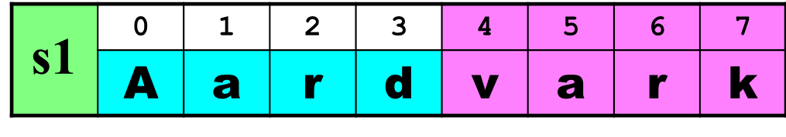
s3 becomes "vark"

There is more that can be done with substrings. You have just finished specifying a startindex and endindex within an existing string to get a desired substring. It is also possible to go into the opposite direction. This means that you start with a specified substring and determine if it exists in another string, and if so, where?

Method indexOf behaves like the find function of a word processor. The method returns the index of the first occurrence of the substring. Program Java0805.java, in figure 8.7, uses "car" as the search string. First a search is done in string "racecar", where there is only a single occurrence of the substring.

A second search for "car" is used in "racecar in the carport", which has two occurrences of the substring. Third, "car" is used for a search with the "qwerty" string and will return -1 since the substring is not found.

Figure 8.7
// Java0805.java
// This program shows the <indexOf> method, which returns the index of the first
// occurrence of the string argument or -1 if the string is not found.
public class Java0805
{
public static void main (String args[ ])
{
String s1 = "racecar";
String s2 = "racecar in the carport";
String s3 = "car";
int index1 = s1.indexOf(s3);
int index2 = s2.indexOf(s3);
int index3 = s3.indexOf("qwerty");
System.out.println("With \"" + s1 + "\" car starts at " + index1);
System.out.println("With \"" + s2 + "\" car starts at " + index2);
System.out.println("With \"" + s3 + "\" Qwerty shows up at " + index3);
}
}

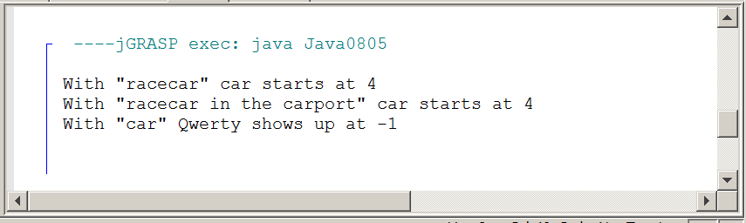

String method indexOf with 1 parameter
indexOf returns the first occurrence of a substring.

s1.indexOf(“hum”); returns 0
s1.indexOf(“ku”); returns 10
s1.indexOf(“qwerty”); returns -1

If the substring cannot be found a value of -1 is returned.

It is entirely possible that the desired substring occurs multiple times. Consider substring "is" in string "Mississippi" and you this can easily happen. This is especially true when the string has multiple words.

Java has an overloaded indexOf method with a second parameter, which indicates the index where the searching starts. Program Java0806.java, in figure 8.8, shows both indexOf methods.

Figure 8.8
// Java0806.java
// There is a an overloaded <indexOf> method, which uses a
// second parameter to indicate the start of the search

public class Java0806
{
public static void main (String[ ] args)
{
String str = "Mississippi is a state and it is a river.";
System.out.println(str.indexOf("is"));
System.out.println(str.indexOf("is",2));
System.out.println(str.indexOf("is",10));
System.out.println(str.indexOf("is",15));
}
}

Figure 8.8 Continued
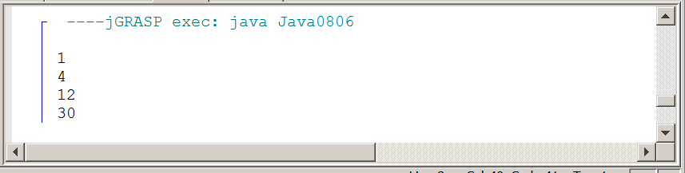

String method indexOf with 2 parameters
(indexOf is overloaded)
indexOf also returns the first occurrence of a substring
on or after a specified index.

s1.indexOf(“hum”,3); returns 4
s1.indexOf(“ku”,12); returns 14

s1.indexOf(“hum”,4); returns 4
s1.indexOf(“ku”,14); returns 14

s1.indexOf(“hum”,8); returns -1
s1.indexOf(“ku”,17); returns -1

If the substring cannot be found on or after a specified index
a value of -1 is returned.

8.5 Converting Strings

In this section we will examine how to change strings into other data types and how to change other data types into strings. Many program languages seem to prefer string data keyboard entry and some conversion is necessary to allow numerical computation. The need of this type of conversion will make more sense in the future when you learn how to store data on external devices like a hard drive or other device.

Program Java0807.java, in figure 8.9, constructs four strings and each string uses the valueOf method. This method is overloaded and the program example shows how to convert an int, double, boolean and char primitive data types, into a String object. Method valueOf is a static or class method, which is evidenced by the String class identifier rather than an object identifier.

Figure 8.9
// Java0807.java
// This program demonstrates the <valueOf> method of the String class,
// which is shown to convert four data types to a string.
// Note that <valueOf> is a static method and must be called using <String.valueOf>.
public class Java0807
{
public static void main (String[ ] args)
{
String s1 = String.valueOf(1000);
String s2 = String.valueOf(123.321);
String s3 = String.valueOf(true);
String s4 = String.valueOf('A');
String s5 = s1 + s2;
System.out.println("s1: " + s1);
System.out.println("s2: " + s2);
System.out.println("s3: " + s3);
System.out.println("s4: " + s4);
System.out.println("s5: " + s5);
}
}

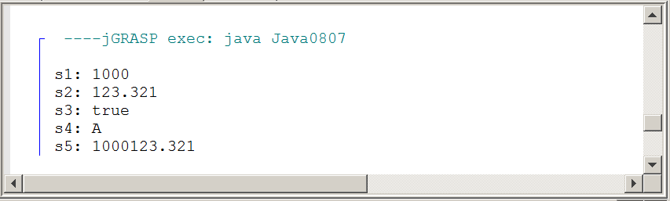
String static method valueOf
String s1 = String.valueOf(1000);
String s2 = String.valueOf(123.321);
String s3 = String.valueOf(true);
String s4 = String.valueOf('A');

Method valueOf converts the provided parameter and returns
a string. Four overloaded valueOf methods are displayed.

Note that the valueOf method is a static method that is called with the String class identifier.

Program Java0808.java, in figure 8.10, demonstrates both the parseInt and the parseDouble methods. These methods are shown in this string processing chapter, as well they should, because strings are very much used. However, these two conversion methods are not in the String class. They belong to the Integer class and the Double class. Do not get confused with the simple data types, int and double. Integer and Double are bona-fide classes, as the starting upper-case letters indicates.

Figure 8.10
// Java0808.java
// This program converts string values to int and double values using
// the <parseInt> and <parseDouble> methods of the <Integer> and <Double> classes.

public class Java0808
{
public static void main (String[ ] args)
{
String s1 = "12345";
String s2 = "123.321";
String s3 = "811 Fleming Trail";

int n1 = Integer.parseInt(s1);
double n2 = Double.parseDouble(s2);
// int n3 = Integer.parseInt(s3);

System.out.println(n1 + " + " + n1 + " = " + (n1 + n1));
System.out.println(n2 + " + " + n2 + " = " + (n2 + n2));
// System.out.println(n3 + " + " + n3 + " = " + (n3 + n3));
}
}

Figure 8.10 Continued
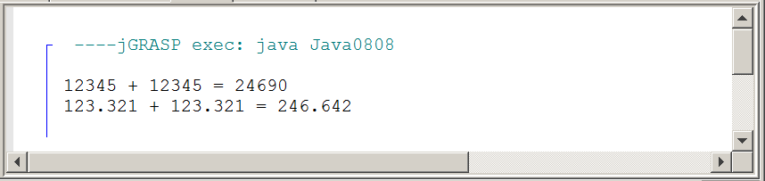

In the previous execution lines 16 and 20 were commented out. These lines involve a strange, but practical experiment. What happens if there is a string of characters, like a street address? For example, if the string is "811 Fleming Trail". The string has numerical characters that can be converted and it also has many non-numerical characters. Remove the comments and check the result, which is shown in figure 8.11. The program compiles fine, but crashes after some initial output and creates runtime Exception error messages.

Figure 8.11
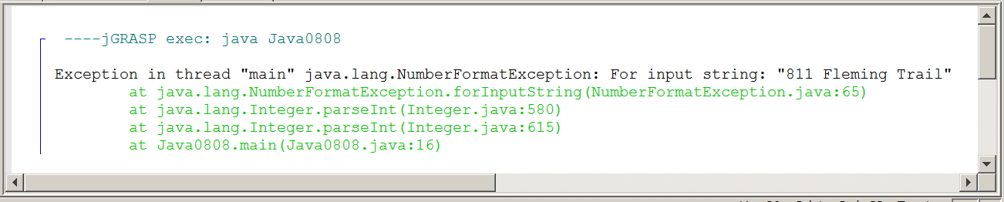

Integer parseInt and Double parseDouble methods
int n1 = Integer.parseInt(s1);
double n2 = Double.parseDouble(s2);

Method parseInt converts a string into an integer.
Method parseDouble converts a string into a double.

8.6 Comparing Strings

This section will start by comparing the equality of two strings. Two strings "Foxtrot" and "Waltz" are literal strings coded into the program. These two strings will be compared to string "Foxtrot" that will be entered at the keyboard during executing program Java0809.java, in figure 8.12. Would you expect that both strings are considered not equal?

Figure 8.12
// Java0809.java
// This program checks equality of strings using the == operator.
// This program has unexpected results.

import java.util.Scanner;

public class Java0809
{
public static void main (String[ ] args)
{
Scanner input = new Scanner(System.in);
System.out.print("Enter a string ===>> ");
String s1 = input.nextLine();
String s2 = "Waltz";
String s3 = "Foxtrot";
System.out.println();

if (s1 == s2)
System.out.println(s1 + " equals " + s2);
else
System.out.println(s1 + " does not equal " + s2);
if (s1 == s3)
System.out.println(s1 + " equals " + s3);
else
System.out.println(s1 + " does not equal " + s3);
System.out.println();
}
}

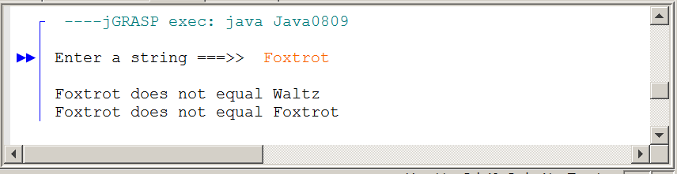
Program Java0810.java, in figure 8.13, uses the equals method to compare two strings. The equals operator == is meant for simple data types, like int, char, double and boolean. The equals method is designed to check object equality. This is yet another example that String is not a simple type, but a class.

Figure 8.13
// Java0810.java
// This program demonstrates the <equals> method, which is capable of
// testing equality of string objects correctly.

import java.util.*;

public class Java0810
{
public static void main (String[ ] args)
{
Scanner input = new Scanner(System.in);
System.out.print("Enter a string ===>> ");
String s1 = input.nextLine();
String s2 = "Waltz";
String s3 = "Foxtrot";
System.out.println();

if (s1.equals(s2))
System.out.println(s1 + " equals " + s2);
else
System.out.println(s1 + " does not equal " + s2);
if (s1.equals(s3))
System.out.println(s1 + " equals " + s3);
else
System.out.println(s1 + " does not equals " + s3);
System.out.println();
}
}

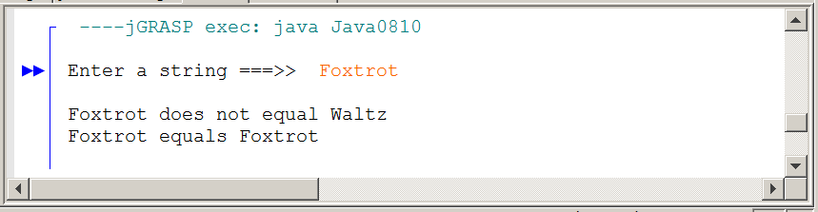

It is easy to state that the == operator checks equality for simple data types and the equals method checks equality for class objects. Does that make any sense? After all, isn't equality the same equality no matter what values are compared? That may be a logical question, but the problem is in the comparing.

When you look at two numbers, like 100 and 100 it seems easy to determine equality. Likewise look at "Foxtrot" and "Foxtrot" and there appears no difficulty in seeing that those are identical string values. The problem here is that you look at these values like a person and the computer does not see with eyes and compares something entirely different than a person.

Primitive data types store values and objects store references to the memory locations where values are stored. It helps to view these memory locations as storing shallow or immediate values and deep values.

Look at the diagram in figure 8.14 where you see two memory locations. There is memory allocated for two int variables n1 and n2. At each one of these two memory locations the same 1000 is stored. The statement if (n1 == n2) checks to see what values are stored at n1 and n2 and compares them. We can say that the shallow or immediate values are compared.

Figure 8.14

n1 (int) n2 (int)

1000
1000

It is a different story for String objects. Figure 8.15 shows greater complexity in storing the String values. The immediate values of s1 and s2 are not String values, but memory references. These memory references are the deeper memory locations where the actual String values of "Foxtrot" are stored.

When the statement if (s1 == s2) is used, Java checks the equality of the immediate values of s1 and s2 just like it was done with n1 and n2. The immediate values are a base-16 memory reference and dff6ccd and 601bb1 are not equal. This is what the computer sees, compares and then concludes that s1 is not equal to s2.

The equals method, used by the String class, has been designed to ignore the shallow values and compare the deep values of s1 and s2, which is where values, like "Foxtrot" and "Waltz" are stored. The result is that now the equality is properly evaluated.

Figure 8.15

s1 s2

dff6ccd 601bb1

@601bb1
@dff6ccd

Waltz

Foxtrot

String equals method
if (s1.equals(s2))

Method equals returns true if s1 equals s2, and false otherwise.

The Java String class has a compareTo method, which is similar to the equals method. Both methods determine equality, but the difference is that compareTo is able to indicate the relative distance between strings that are not equal. You may find distance-between-strings a rather peculiar concept. The relative distance is an integer value based on the difference of the character values. This means that equal strings have a distance of 0. Strings that start with a and b have a distance of 1 and strings that start with A and Z have a distance of 25.

The compareTo method also has the ability to identify whether a compared string is greater or lesser and uses a negative sign to indicate lesser strings. Program Java0811.java, in figure 8.16, will help to clarify this negative business.

Figure 8.16
// Java0811.java
// This program demonstrates the <compareTo> method, which returns an integer value.
// The returned value indicates which string alphabetically goes before the other.
// If the value is negative, the original string goes first.
// If the value is positive, the parameter string goes first.
// If the value is zero, both strings are equal.

public class Java0811
{
public static void main (String[ ] args)
{
String s1 = "AARDVARK";
String s2 = "ZEBRA";
String s3 = "AARDVARK";
String s4 = "BART";

int value1 = s1.compareTo(s2);
int value2 = s1.compareTo(s3);
int value3 = s2.compareTo(s1);
int value4 = s1.compareTo(s4);

System.out.println("value1: " + value1);
System.out.println("value2: " + value2);
System.out.println("value3: " + value3);
System.out.println("value4: " + value4);
System.out.println();
}
}

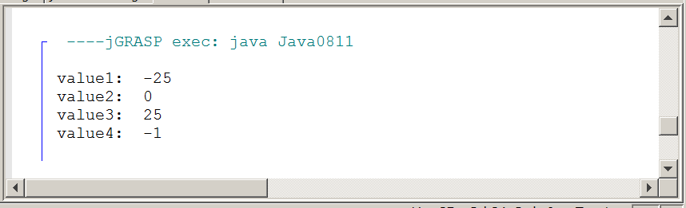

The compareTo method checks its own String relative to the String argument. If its own string value is less (alphabetically speaking) than the string argument, the integer returned is a negative value, and otherwise it is zero or positive.

String compareTo method
int distance = s1.compareTo(s2);

Method compareTo returns 0 if s1 equals s2,
otherwise an integer is returned based on the difference between s1 and s2.

If the returned value is negative, it means that s1 goes before s2.
If the returned value is positive, it means that s1 goes after s2.

8.7 Altering Strings

At first this section may seem repetitive. Have we not already altered strings into other values from string to integer and vice versa? We did, but we really did not change the actual string appearance. We changed the data type of the string.

Now we are going to change the string value to a similar, but different value in two different ways. The first change is the issue with white space. White space is invisible and can cause headaches when properly processing String objects. The most common white space is the blank space by itself, like " " or any blank spaces that appear before or after words, like "Number: ".

The comparison of two strings for equality or inequality can be incorrect even as the two strings appear equal to human eyes. The computer sees the white space and the white space characters become part of the total string. Java provides a trim method to solve this problem. Program Java0812.java, in figure 8.17, has two strings, which store Aardvark. The second Aardvark string includes some white spaces before and after the visible string.

Figure 8.17
// Java0812.java
// This program demonstrates using the <trim> method, which removes all
// white space characters at the beginning and end of a string object.
// NOTE: "White Spaces" are invisible characters like spaces and tabs.

public class Java0812
{
public static void main (String args[ ])
{
String s1 = "AARDVARK";
String s2 = " AARDVARK\t\t";
String s3 = s1.trim();
String s4 = s2.trim();

System.out.println("start" + s1 + "end");
System.out.println("start" + s2 + "end");
System.out.println("start" + s3 + "end");
System.out.println("start" + s4 + "end");
System.out.println();

System.out.println("s1 length: " + s1.length());
System.out.println("s2 length: " + s2.length());
System.out.println("s3 length: " + s3.length());
System.out.println("s4 length: " + s4.length());
}
}

Figure 8.17 Continued
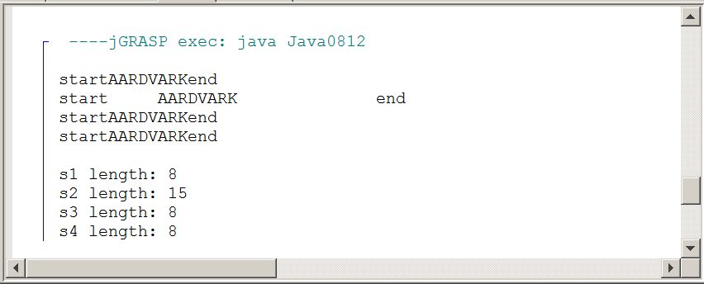

Accurate string comparison can also be confused by the difference between upper-case and lower-case letters. Comparisons of characters is based on their numerical ASCII code or UniCode values. Upper-case letters and lower-case letters have different numerical codes. If it is desired to sort string data alphabetically in ascending order, the computer will happily conclude that ZULU comes before aardvark.

This problem is addressed by program Java0813.java, in figure 8.18, using methods toUpperCase and toLowerCase. When all characters in the string are upper-case or lower-case, proper comparisons and sorting become easier.

Figure 8.18
// Java0813.java
// This program demonstrates using the <toUpperCase>
// and <toLowerCase> methods.

public class Java0813
{
public static void main (String[ ] args)
{
String s1 = "aardVARK for SALE, only $12.00!";
String s2 = "AARDvark FOR sale, ONLY $12.00!";
String s3 = s1.toUpperCase();
String s4 = s2.toLowerCase();

System.out.println(s1);
System.out.println(s2);
System.out.println(s3);
System.out.println(s4);
}
}

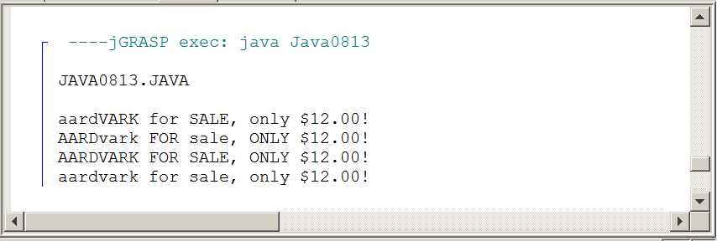

String trim method
String s1 = " Kathy Jones\t\t"
String s2 = s1.trim();

Method trim removes the white space in front and behind a string. White space are invisible characters, like blank spaces and tabs.

s2 becomes "Kathy Jones"

String toUpper Case and toLowerCase methods
String s1 = "AARDvark";
String s2 = "aardVARK";
String s3 = s1.toUpperCase();
String s4 = s2.toLowerCase();

Method toUpperCase returns a string with upper-case letters.
Method toLowerCase returns a string with lower-case letters.

s3 becomes AARDVARK
s4 becomes aardvark

Any characters that are not letters will be ignored by both methods and returned in their same relative string position.

Altering the Original String Object
Remember, String methods do not alter the original String object. They return an altered copy of the String object.
To alter the original String object, you need a statement that assigns the new copy back to the original object.

Examples:
s1 = s1.toUpperCase();
s2 = s2.toLowerCase();
s3 = s3.trim();
s4 = s4.substring(1,5);

AP® Computer Science Examination Alert
Java has a large selection of String methods and some of them were shown in this chapter.

Not all of these methods will be tested. Only the following methods are part of the AP® Java testing Subset:

compareTo - equals - length - substring - indexOf

8.8 Adding Methods to the Utility Library

A simple utility library was created in the previous chapter with just 3 methods. Now that we understand String methods, we can add some more useful methods. System.out.println is fine, but it always displays text left-justified. What if you want the text right-justified or centered? Let us say you wish to display the string “Hello World.” right-justified. The length method tells us this string has 12 characters (do not forget to count the space and the period). A text window is 80 characters wide. 80 – 12 = 68 extra spaces that need to be printed before the string to right-justify it. If you want to center the string, you just make one change. Instead first displaying 68 blank spaces, you divide is by 2 and display 34 blank spaces.

Figure 8.19 shows the updated Utility.java file. Note that graphics methods and text methods coexist nicely in the same file. Program Java0814.java, in figure 8.20, demonstrates the new rightJustify, center, and skip methods.

Figure 8.19
// Utility.java
// This file contains useful methods that can be used by several different programs.

import java.awt.*;
import java.applet.*;

public class Utility
{
public static int random(int min, int max)
{
int range = max - min + 1;
int randomNumber = (int)(Math.random() * range) + min;
return randomNumber;
}

public static void setBackground(Graphics g, Color c)
{
g.setColor(c);
g.fillRect(0,0,1000,650);
}

public static void setRandomColor(Graphics g)
{
int red = random(0,255);
int green = random(0,255);
int blue = random(0,255);
g.setColor(new Color(red, green, blue));
}

public static void skip(int n)
{
for (int j = 1; j <= n; j++)
System.out.println();
}

public static void rightJustify(String text)
{
int len = text.length();
int numSpaces = 80 - len;
for (int j = 1; j <= numSpaces; j++)
System.out.print(" ");
System.out.println(text);
}

public static void center(String text)
{
int len = text.length();
int numSpaces = (80 - len) / 2;
for (int j = 1; j <= numSpaces; j++)
System.out.print(" ");
System.out.println(text);
}
}

Figure 8.20
// Java0814.java
// This program utilized the new methods added to the <Utility> class.

public class Java0814
{
public static void main (String args[ ])
{
Utility.skip(3);
System.out.println("Text output is left-justified by default.");
Utility.skip(4);
Utility.rightJustify("This text is right-justified.");
Utility.skip(5);
Utility.center("This text is centered.");
Utility.skip(2);
}
}

Figure 8.20 Continued
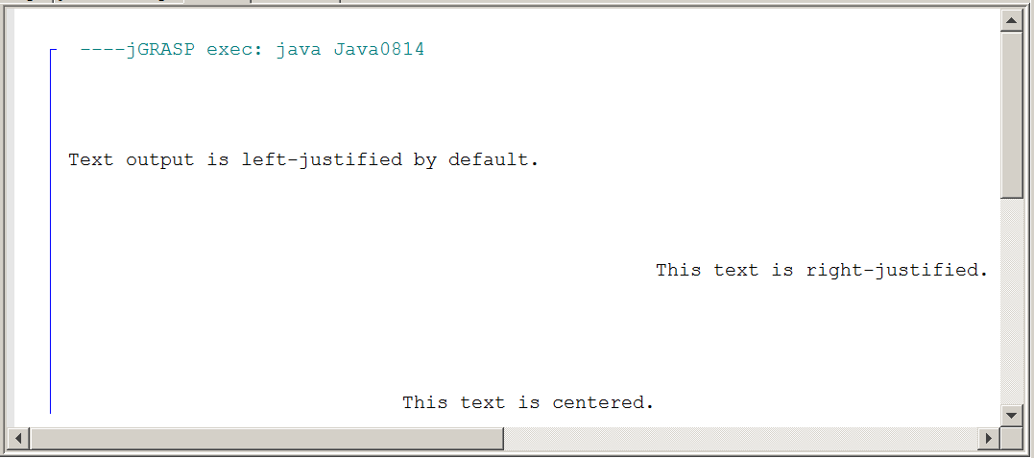

8.9 Introduction to the Magpie AP® Lab

An introductory computer science course, like AP® Computer Science revolves around programming skills. This means you will be seeing many program examples. The majority of these program examples are intentionally small. Each program focuses on one particular programming concept or one step in a sequence of steps that builds up to a larger program.

AP® Computer Science is both a theoretical course that teaches computer science concepts and a practical programming course that expects students to understand the logic of a substantial program. All AP® Computer Science students are expected to complete a substantial number of hours working on lab assignments and for many years the curriculum and the AP® Examination included a Case Study. The previous case study was called GridWorld Case Study and it was tested for the last time during the May, 2014 AP® Examination. Starting with the 2014-2015 school year GridWorld was replaced not by a new, single case study, but by three completely different programs.

These three AP® Labs will not be tested in the manner of all of the previous case studies. Specific questions about these AP® Labs will not appear. What students can expect are questions on topics, such as string processing, two-dimensional arrays handling, program design and other topics, which are handled in considerable detail by these three AP® labs.

The first AP® Lab is the Magpie Lab. It is a program that revolves around the creation of a Chatbot program. Such a program allows a program user to interact with the computer. This can be done with keyboard input and computer monitor response. It can also be done more sophisticatedly talking to a robot, which responds with spoken speech. The cover page of the Magpie Chatbot Lab Student Guide, as distributed by the College Board®, is shown below.

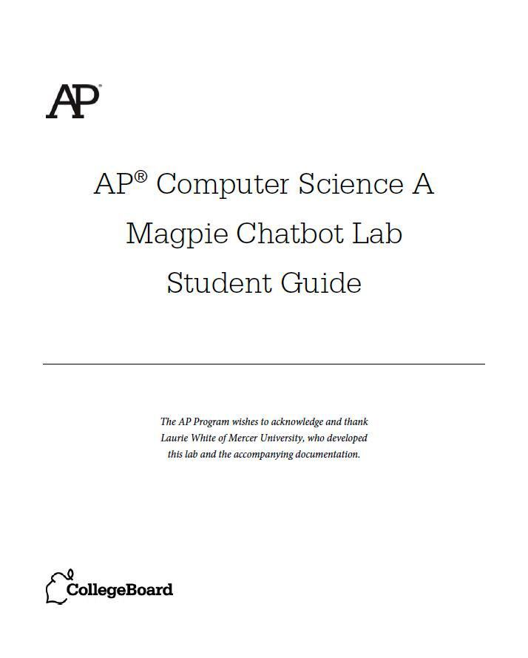

So why is it a Magpie Chatbot? Apparently, magpies chatter a lot. You may have heard the expression, “Chattering like a magpie”.
Exposure Java and the AP® Labs
The AP® Computer Science Test Development Committee has coordinated the creation of these new AP® Labs for the College Board®.

The first AP® Lab, called the Magpie Chatbot program along with its documentation, is developed by Laurie White of Mercer University.

Exposure Java and its Authors Leon Schram (father) and John Schram (son) include the three AP® labs in this textbook, but had no part in its
development.

What has been done in Exposure Java is to present the AP® Labs throughout the curriculum where appropriate. The labs are not shown complete, but rather a smaller sequence of incomplete versions of these labs are introduced to help in understanding the concepts presented by each lab.

Even though, the initial lab introductions, and various stages along the way are different from the AP® labs presented by the College Board®, the final stages shown in Exposure Java are exactly, like the College Board® versions.

The aim for such robots is to come as close to human responses as possible. In 1950 a famous programmer, Alan Turing, devised a test for artificial intelligence. The essence of Turing's argument is that a person is presented with the opportunity to ask questions on the computer to two different recipients. Each one of the question recipients answers the questions. One respondent is a person and the other respondent is a computer. If a questioner thinks that both respondents are human, then artificial intelligence is achieved.

Magpie Program Goal
The goals of the Magpie program are to give students
an opportunity to use string processing and compound control structures in a program.
It is not the goal of this first AP® lab to create a computer program that will pass the Turing test and achieve a considerable level of artificial intelligence.

Now having said that the Magpie programs are not meant to pass the Turing test, we will still try to steadily improve the program to reach a greater degree of "humanness." The early stages of this program actually will not much resemble any kind of Chatbot, but the first stages are to comprehend the structure of the Magpie program such that we start simple and steadily advance to complex.

Each one of these Magpie class stages will be tested by using a corresponding MagpieRunner class. The two classes will be presented in two separate files. This pattern will follow in all the Magpie stages. The first stage is presented with program Magpie2a.java, in figure 8.21. It is a class with method getGreeting. This class is followed by program MagpieRunner2a.java, in figure 8.22.

Figure 8.21
/*
* A program to carry on conversations with a human user.
* This is the initial version that only provides a greeting.
****************************************************************
* author Laurie White
* version April 2012
* Divided into stages and altered July 2014 by Leon Schram
*/

public class Magpie2a
{
public String getGreeting()
{
return "Hello, let's talk.";
}
}

Figure 8.22
/*
* A simple class to run the Magpie class.
* The "runner" classes test the Magpie Classes.
***********************************************************
* author Laurie White
* version April 2012
* Divided into stages and altered July 2014 by Leon Schram
*/
public class MagpieRunner2a
{
public static void main(String[ ] args)
{
Magpie2a maggie = new Magpie2a();
System.out.println (maggie.getGreeting());
}
}

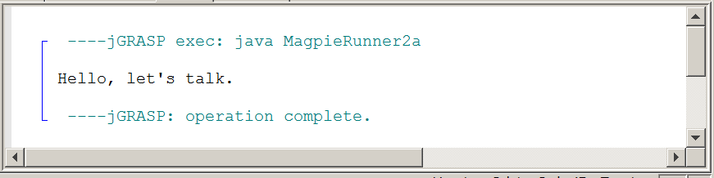

The testing program, called MagpieRunner2a, creates a Magpie2a object and calls its only method. This first stage is primarily used to start simple and show the interaction with the Magpie class and its testing program, MagpieRunner.

8.10 Initial Chatbot Response

The next stage makes a pretty good jump. It is now possible to start interacting with our clever chatbot and observe the responses. This will require changes in both the MagpieRunner class testing program and the Magpie class. First, look at the testing program, MagpieRunner2b.java, in figure 8.23. The greeting is presented as before and then the program user can interact by typing some question or statement after the greeting. This process will continue until the user enters Bye. Be aware that right now the responses are case sensitive. This means that the string "no" is not the same as the string "No". The testing program provides a loop that seeks user input. Each input is compared to the string Bye, which becomes the flag to stop the program. bye will not stop the program.

Figure 8.23
/*
* A simple class to run the Magpie class.
* This version tests the Magpie2b class.
***********************************************************
* author Laurie White
* version April 2012
* Divided into stages and altered July 2014 by Leon Schram
*/

import java.util.Scanner;

public class MagpieRunner2b
{
public static void main(String[ ] args)
{
Magpie2b maggie = new Magpie2b();

System.out.println (maggie.getGreeting());
Scanner in = new Scanner (System.in);
String statement = in.nextLine();
while (!statement.equals("Bye"))
{
System.out.println (maggie.getResponse(statement));
statement = in.nextLine();
}
}
}

So what will the Magpie program do in response to anything that is typed by the program user? Nonsense, random answers, are simple, but the aim is to create a fairly sophisticated Chatbot that makes reasonable responses to the user's input.

We are still in the earlier stages. Look at program Magpie2b.java, in figure 8.24 and then look at the various responses shown in figure 8.25.

Figure 8.24
/*
* A program to carry on conversations with a human user.
* Version 2b provides the following responses:
* "Why so negative" when substring "no" is found.
* "Tell me more about your family" when relatives are found.
* "I don't know what to say" otherwise.
***********************************************************
* author Laurie White
* version April 2012
* Divided into stages and altered May 2014 by Leon Schram
*/

public class Magpie2b
{
public String getGreeting()
{
return "Hello, let's talk.";
}

public String getResponse(String statement)
{
String response = "";
if (statement.indexOf("no") >= 0)
{
response = "Why so negative?";
}
else if (statement.indexOf("mother") >= 0
|| statement.indexOf("father") >= 0
|| statement.indexOf("sister") >= 0
|| statement.indexOf("brother") >= 0)
{
response = "Tell me more about your family.";
}
else
{
response = "I don't know what to say.";
}
return response;
}
}

Figure 8.25
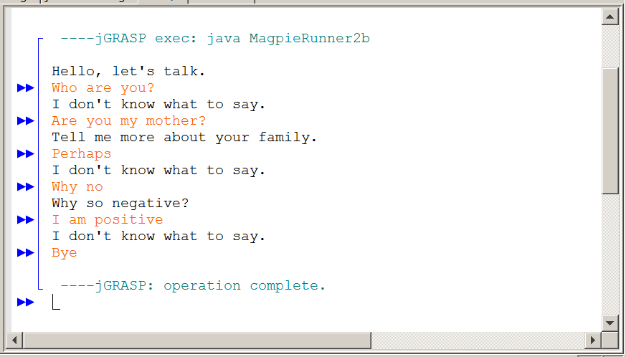

The method responsible for the computer response to the user is getResponse. At this Chatbot stage there are only three types of responses possible.

1. The computer responds with “Why so negative?”
This response is a consequence of finding the substring "no" anywhere in the user response. The indexOf method is not looking for the word "no", but the substring "no". Words like “notice”, “know” and “not” all contain "no". Keep in mind that "No" will not work.

2. The computer responds with “Tell me more about your family.”
The family response is selected anytime the substring "mother", "father", "sister" or "brother" is found somewhere in the input of the program user.

3. The program will respond with “I don't know what to say.” This is the default response the computer gives when the substring "no" or family substrings are not used.

8.11 Chatbot Adds Random Responses

It is quite easy to realize that you are communicating with a computer and not a very sophisticated one at that. The aim of the Magpie program is to steadily improve and make its responses more reasonable. A response of "I don't know what to say" may well be what human beings would say, but not continuously.

The MagpieRunner programs will not be shown anymore. At each stage the program is identical in functionality. The only difference is that an object of the new version of the Magpie class is constructed.

In the Magpie2c class the program continues to check for the string "no" and it also continues to responds to family input. The key change is that now the getRandomResponse method is called as a third option.

There are a total of four responses. The Math.random method is used to randomly select a response. The responses are intentionally selected to be very general and say very little, as you see in program Magpie2c.java, in figure 8.26.

Figure 8.26
/*
* A program to carry on conversations with a human user.
* Version 2c provides the following responses:
* "Why so negative" when substring "no" is found.
* "Tell me more about your family" when relatives are found.
* One of four random responses otherwise.
******************************************************************
* author Laurie White
* version April 2012
* Divided into stages and altered May 2014 by Leon Schram
*/

public class Magpie2c
{
public String getGreeting()
{
return "Hello, let's talk.";
}

public String getResponse(String statement)
{
String response = "";
if (statement.indexOf("no") >= 0)
{
response = "Why so negative?";
}

else if (statement.indexOf("mother") >= 0
|| statement.indexOf("father") >= 0
|| statement.indexOf("sister") >= 0
|| statement.indexOf("brother") >= 0)
{
response = "Tell me more about your family.";
}
else
{
response = getRandomResponse();
}
return response;
}

private String getRandomResponse()
{
final int NUMBER_OF_RESPONSES = 4;
double r = Math.random();
int whichResponse = (int)(r * NUMBER_OF_RESPONSES);
String response = "";

if (whichResponse == 0)
{
response = "Interesting, tell me more.";
}
else if (whichResponse == 1)

{
response = "Hmmm.";
}
else if (whichResponse == 2)
{
response = "Do you really think so?";
}
else if (whichResponse == 3)
{
response = "You don't say.";
}
return response;
}
}

Look at the responses in figure 8.27. Consider each computer response after the keyword input by the program user. Does the computer response make sense? Now it makes no sense in what a human being would say, but can you check the current version of the Magpie2c class and determine that this is to be expected?

Figure 8.27
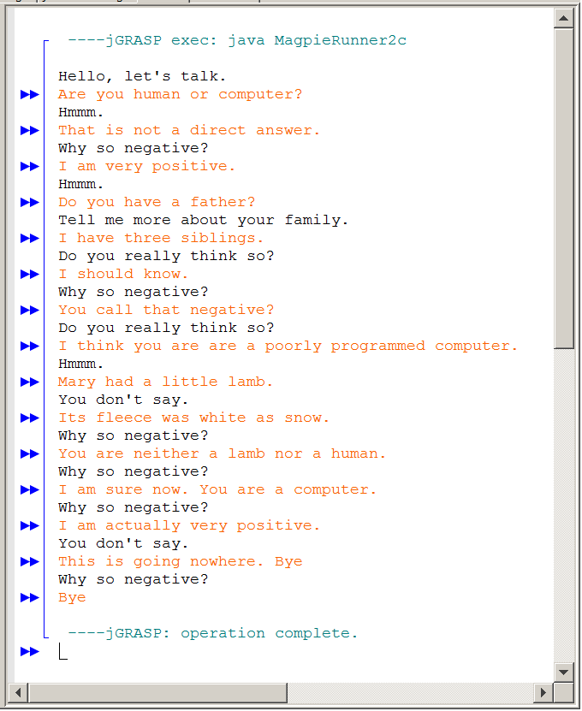

The responses of this interchange may not be what you desire, but the computer is precisely doing what it is programmed to do. Always remember a computer only does what you tell it to do, not what you want it to do.

This is a fundamental problem with beginning programmers. They know what the computer should do. Is that not sufficient? OK, forget computers. How about human communication? Once again people know what they want to communicate, but that does not always guarantee correct understanding.
At this level our simple Chatbot has three types of responses:

1. “Why so negative?”
(Consequence of using string "no" anywhere in the input)

2. “Tell me more about your family.”
(Response to finding mother, father, sister or brother in the input)

3. One of the following responses delivered randomly:
“Interesting, tell me more.”
“Hmmm.”
“Do you really think so?”
“You don't say.”
(This happens when choices 1 and 2 do not apply).

8.12 Improving the Negative Response

There is something peculiar about the frequent “Why so negative?” response. Method getResponse, from Magpie3a.java, is shown in figure 8.28. The problem is connected with the functionality of the indexOf method. This method looks for the substring "no" and it does not look to see if this is a stand-alone word. This is very telling of an ignorant computer, who blindly provides the programmed response. Alan Turing would not be impressed.

Figure 8.28
public String getResponse(String statement)
{
String response = "";
if (statement.indexOf("no") >= 0)
{
response = "Why so negative?";
}
else
{
response = "I don't know what to say.";
}
return response;
}

Now run program MagpieRunner3a.java. You will note the output is very similar to the 2b stage. Try a variety of inputs and use the same inputs that are shown in figure 8.29 along with some extras of your own selection. What do you notice?

Figure 8.29
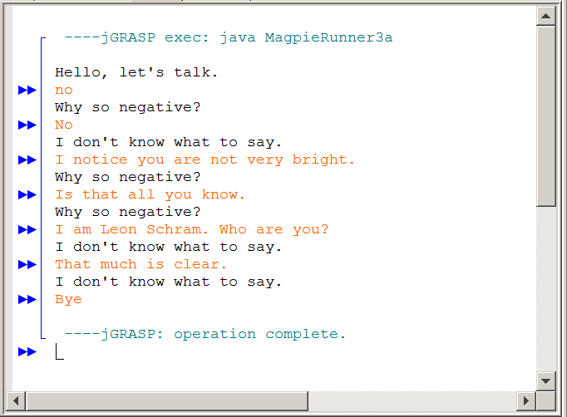

What you should notice is that any word, like “not”, “notice”, “normal”, “now”, “snow”, and “know” are being interpreted as negative, simply because they contain the substring “no”. This caused the frequent “Why so negative?” responses in the previous outputs. While this is not a problem in the case of “not”, it is definitely a problem for the other words. You should have noticed something else. “No” did not generate a negative response. That is because the getResponse method is currently case-sensitive. We need something much more sophisticated. Look at the improved getResponse method from Magpie3b.java in figure 8.30.
Figure 8.30
public String getResponse(String statement)
{
String response = "";
if (statement.length() == 0)
{
response = "Say something, please.";
}
else if (findKeyword(statement, "no") >= 0)
{
response = "Why so negative?";
}
else
{
response = "I don't know what to say.";
}
return response;
}

By itself it does not look much improved. The difference is with the new findKeyword helper method shown in figure 8.31. There are several things this new method does. First, the user’s input phrase is trimmed to remove any leading or trailing white space characters. Second, both the input phrase and the desired goal - "no" in this case - is converted to lowercase to eliminate the case-sensitivity issues.

Then the program starts at the beginning of the trimmed, lowercase statement and looks for the word “no”. Assuming it is found, a check is made to insure that the characters before and after “no” are not letters. This tells us “no” is a word on its own. In that case the index is returned.

This sounds terrific, but the truth is that the program only works for some situations. As long as "no" is in the middle of the phrase, it works quite well. There is also the issue if "no" is found first inside a word like notice and know. In that case the method does not continue and see if there are other possibilities.

Computer programming is quite challenging precisely, because there are many cases to consider. For now there is a good start and we do find the word "no" by itself in many phrases, but there is more work to be done before this program can even remotely call itself a chatbot.

Run the program and enter some sentences. Keep in mind that this stage has removed the random responses to allow a focus on the issue to finding the word “no” correctly. You should notice that words like “not” no longer trigger the negative response.

Figure 8.31
private int findKeyword(String phrase, String goal)
{
phrase = phrase.trim();
phrase = phrase.toLowerCase();
goal = goal.toLowerCase();
int psn = phrase.indexOf(goal);
if (psn >= 0)
{
String before = " ";
String after = " ";
before = phrase.substring(psn - 1, psn);
after = phrase.substring(psn + goal.length(),psn + goal.length() + 1);
boolean beforeOK = before.compareTo("a") < 0 || before.compareTo("z") > 0;
boolean afterOK = after.compareTo("a") < 0 || after.compareTo("z") > 0;
if (beforeOK && afterOK)
{
return psn;
}
}
return -1;
}

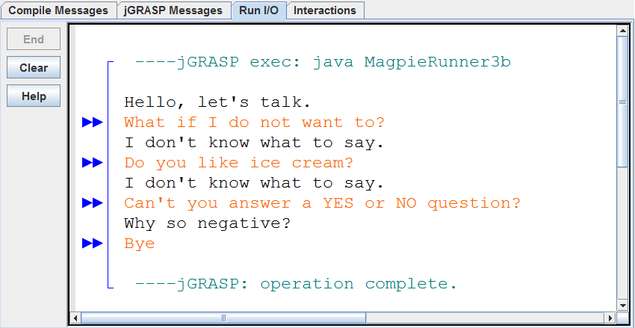

The output may give the impression that we have properly dealt with the “no” issue; however, we do need to consider 2 special cases. What if “no” is at the very beginning of the statement? That would mean there is no character before it to check. It is the same story if “no” is at the end of the statement. Then there is no character after it to check.

Now run program MagpieRunner3b.java and check for the word "no" at the start, at the end and in the middle of the phrase. These outputs are shown in Figure 8.32.

Figure 8.32
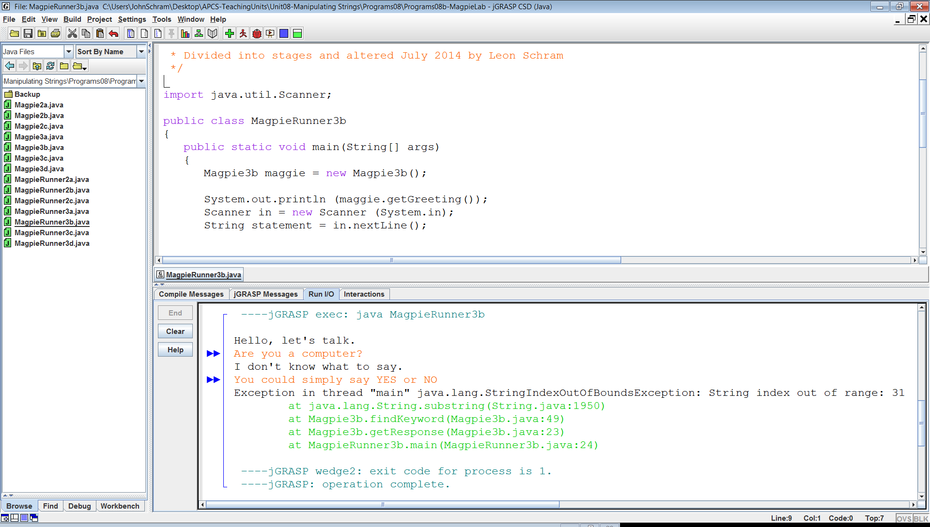
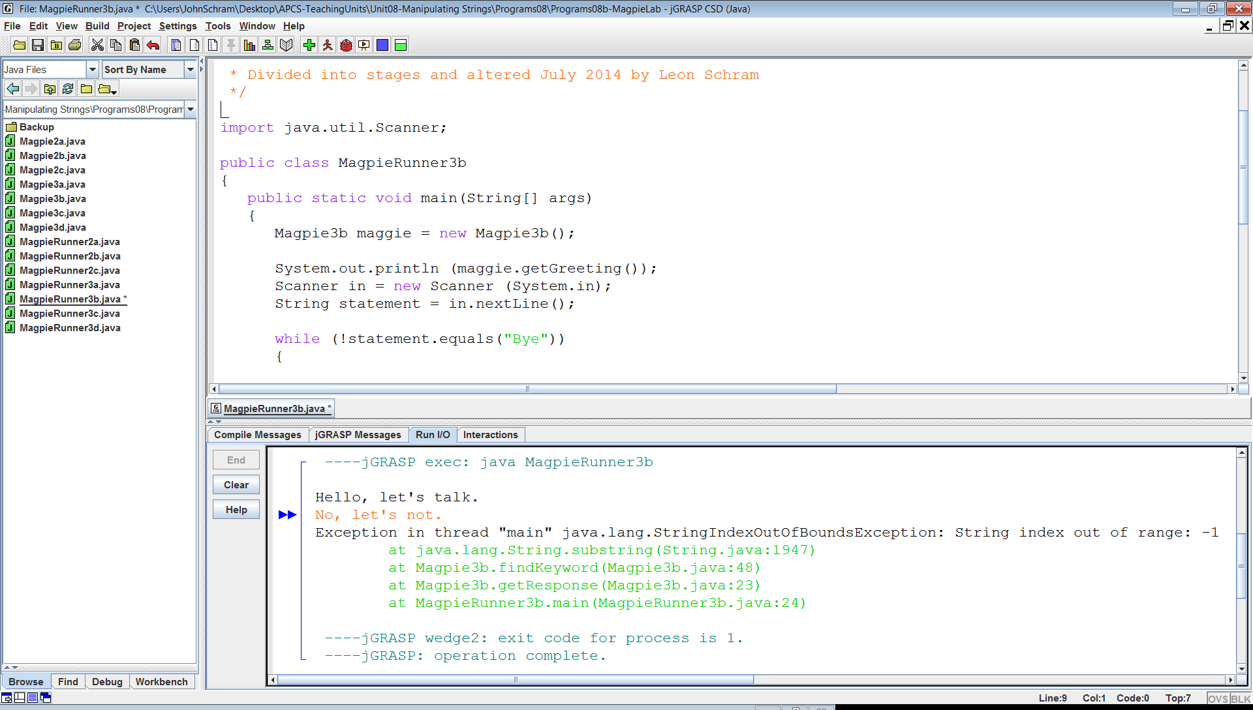

This time the complete Magpie3c class is shown in figure 8.33. There are now three if statement to check for three cases.

if (psn == 0) checks to see if the position (psn) of the goal is at the start of the phrase.

The second if statement checks if the goal is at the end of the phrase.

And finally the last if checks if the goal is in the middle, like the previous Magpie3b class.
Figure 8.33
public class Magpie3c
{
public String getGreeting()
{
return "Hello, let's talk.";
}
public String getResponse(String statement)
{
String response = "";
if (findKeyword(statement, "no") >= 0)
{
response = "Why so negative?";
}
else
{
response = "I don't know what to say.";
}
return response;
}
private int findKeyword(String phrase, String goal)
{
phrase = phrase.trim();
phrase = phrase.toLowerCase();
goal = goal.toLowerCase();
String before = " ";
String after = " ";
int psn = phrase.indexOf(goal);
if (psn == 0) // "no" starts the phrase
{
after = phrase.substring(psn + goal.length(),psn + goal.length() + 1);
boolean afterOK = after.compareTo("a") < 0 || after.compareTo("z") > 0;
if (afterOK)
{
return psn;
}
}
else if (psn + goal.length() == phrase.length()) // "no" ends the phrase
{
before = phrase.substring(psn - 1, psn);
boolean beforeOK = before.compareTo("a") < 0 || before.compareTo("z") > 0;
if (beforeOK)
{
return psn;
}
}
if (psn > 0) // "no" is in the middle of the phrase
{
before = phrase.substring(psn - 1, psn);
after = phrase.substring(psn + goal.length(),psn + goal.length() + 1);
boolean beforeOK = before.compareTo("a") < 0 || before.compareTo("z") > 0;
boolean afterOK = after.compareTo("a") < 0 || after.compareTo("z") > 0;
if (beforeOK && afterOK)
{
return psn;
}
}
return -1; // case when "no" is not found
}
}
Figure 8.33 Continued
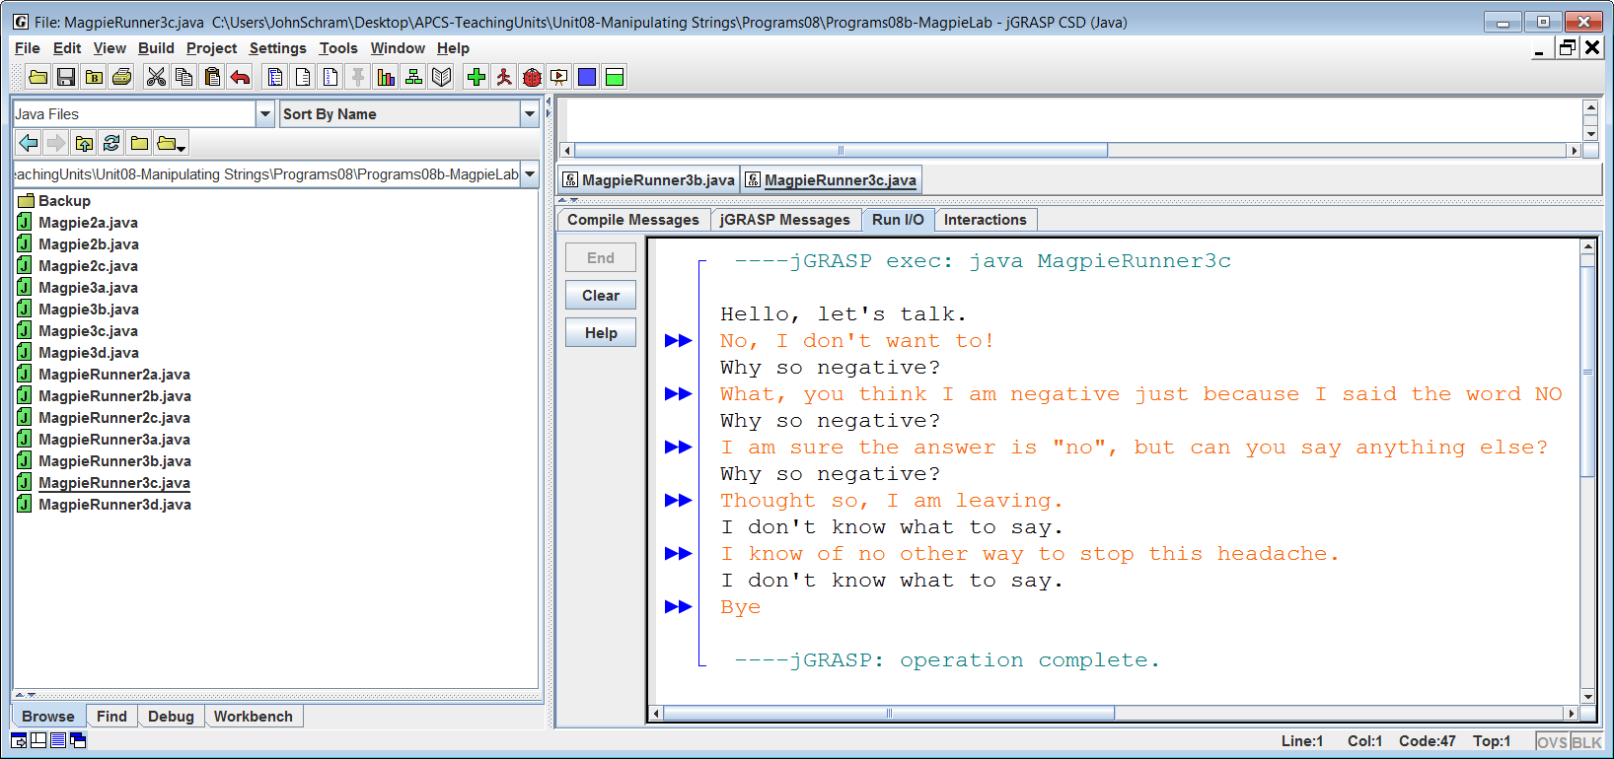

What if “no” was found, but it was part of another word like “not” or “know”? In that case we should not immediately give up because the indexOf method has only given us the location of the first instance of “no” in the string. That will not happen with Magpie3c. That version is not the completed program and only provides if statements. A loop is needed to continue to search for other instances of the "no" substring. The next stage is the solution created by Magpie author Laurie White. The findKeyword method now uses a loop structure to repeat the search process if a proper goal is not found.

The code will look quite different from the previous versions. Professor White uses clever shortcuts to create a concise program code that accomplishes many objectives. Look at the Magpie3d class code, in figure 8.34, carefully and trace the logic. Figure 8.34 shows an execution with a wide variety of inputs to make sure the program can handle a wide variety of cases.

Tracing code can seem very abstract and confusing, especially if you did not write the code. Take out a piece of paper and write down a phrase. Now check the code step-by-step and keep track of the character position that the code is checking each time through the loop.

When you work with a concrete example it is easier to follow the logic. This is also a good technique when you answer computer science questions that involve the output of provided code. You become the computer and you need to know what the code is doing.

Figure 8.34
public class Magpie3d
{
public String getGreeting()
{
return "Hello, let's talk.";
}
public String getResponse(String statement)
{
String response = "";
if (statement.length() == 0)
{
response = "Say something, please.";
}
else if (findKeyword(statement, "no") >= 0)
{
response = "Why so negative?";
}
else
{
response = "I don't know what to say";
}
return response;
}
private int findKeyword(String statement, String goal,int startPos)
{
String phrase = statement.trim();
int psn = phrase.toLowerCase().indexOf(goal.toLowerCase(), startPos);
while (psn >= 0)
{
String before = " ", after = " ";
if (psn > 0)
{
before = phrase.substring(psn - 1, psn).toLowerCase();
}
if (psn + goal.length() < phrase.length())
{
after = phrase.substring(psn + goal.length(),psn + goal.length() + 1).toLowerCase();
}
if (((before.compareTo("a") < 0) || (before.compareTo("z") > 0))
&& ((after.compareTo("a") < 0) || (after.compareTo("z") > 0)))
{
return psn;
}
psn = phrase.indexOf(goal.toLowerCase(),psn + 1);
}
return -1;
}
private int findKeyword(String statement, String goal)
{
return findKeyword(statement, goal, 0);
}
}

Play around with the Magpie3d class. Can you enter a phrase that creates an incorrect response? At this stage the program needs to responds with negative when the word "no" is detected, but not the substring "no" in notice.

Figure 8.35
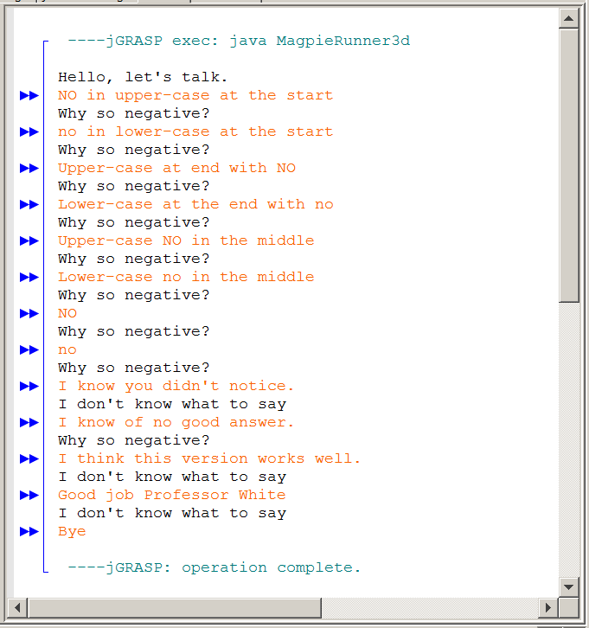
This concludes the Magpie lab for this chapter. The chatbot has many other features that can be improved. We do want to return to the family responses, random responses and other types of responses.

In two future chapters you will learn about arrays, with is a special data type that store multiple elements very conveniently for access. At that future time we will return to the Magpie labs and add more capabilities to our humble Chatbot. At that time you will also be writing several labs that allow you to show your creativity and programming skills to improve the Chatbot.

8.13 Summary

There are many String methods and many were introduced in this chapter. String methods can easily appear similar in behavior and appearance and there are also overloaded methods that may result in confusion. In this summary all the String method summary boxes are repeated in one convenient location so that they can be studied and they can be compared.

The string chapter also introduced first of the three AP® Labs, the Magpie Chatbot lab. This lab request phrase input from the program user and attempts to respond like a human being.

In this chapter the Chatbot has limited capabilities, but it did handle responding to the word "no" very well. Incomplete as the lab is right now, it did allow practice with compound control structures and introduced the important topic of considering cases in writing a program. Much more will be done with this program in future chapters.

Review of String Class Details

String Definition
A string is a collection of characters.

The characters in a string include upper-case and lower-case letters, numerical characters and a large set of characters for a variety of purposes like:

! @ # $ % ^ & * ( ) _ +

String Literal Definition
A string literal is a set of characters delimited with double quotations like:

"Seymour Snodgrass" and "SSN: 123-45-6789"

String method length
int count = str.length();

Method length returns the length or number of characters in the String object.

If str equals "Aardvark" then count becomes 8.

String method substring with 2 parameters
String s1 = "aardvark";
String s2 = s1.substring(j,k);

Method substring returns a set of consecutive characters from string s1, starting at index j, and ending at index k-1.

String s3 = s1.substring(4,7);

s3 becomes "var"

NOTE: The first index of a String is always 0.

String method substring with 1 parameter
(substring is overloaded)
String s1 = “Aardvark”;
String s2 = s1.substring(j);

Method substring returns a set of consecutive characters from String s1, starting at index j, and continuing all the way to the end of the string.

String s3 = s1.substring(4);

s3 becomes "vark"

String method indexOf with 1 parameter
indexOf returns the first occurrence of a substring.

s1.indexOf(“hum”); returns 0
s1.indexOf(“ku”); returns 10
s1.indexOf(“qwerty”); returns -1

If the substring cannot be found a value of -1 is returned.

String method indexOf with 2 parameters
(indexOf is overloaded)
indexOf also returns the first occurrence of a substring
on or after a specified index.

s1.indexOf(“hum”,3); returns 4
s1.indexOf(“ku”,12); returns 14

s1.indexOf(“hum”,4); returns 4
s1.indexOf(“ku”,14); returns 14

s1.indexOf(“hum”,8); returns -1
s1.indexOf(“ku”,17); returns -1

If the substring cannot be found a value of -1 is returned.

String static method valueOf
String s1 = String.valueOf(1000);
String s2 = String.valueOf(123.321);
String s3 = String.valueOf(true);
String s4 = String.valueOf('A');

Method valueOf converts the provided parameter and returns
a string. Four overloaded valueOf methods are displayed.

Integer parseInt and Double parseDouble methods
int n1 = Integer.parseInt(s1);
double n2 = Double.parseDouble(s2);

Method parseInt converts a string into an integer.
Method parseDouble converts a string into a double.
String equals method
if (s1.equals(s2))

Method equals returns true if s1 equals s2, and false otherwise.

String compareTo method
int distance = s1.compareTo(s2);

Method compareTo returns 0 if s1 equals s2,
otherwise an integer is returned based on the difference between s1 and s2.

If the returned value is negative, it means that s1 goes before s2.
If the returned value is positive, it means that s1 goes after s2.

String trim method
String s1 = " Kathy Jones\t\t"
String s2 = s1.trim();

Method trim removes the white space in front and behind a string. White space are invisible characters, like blank spaces and tabs.

s2 becomes "Kathy Jones"

String toUpper Case and toLowerCase methods
String s1 = "AARDvark";
String s2 = "aardVARK";
String s3 = s1.toUpperCase();
String s4 = s2.toLowerCase();

Method toUpperCase returns a string with upper-case letters.
Method toLowerCase returns a string with lower-case letters.

s3 becomes AARDVARK
s4 becomes aardvark

Any characters that are not letters will be ignored by both methods and returned in their same relative string position.

This chapter introduced the first of the three new AP® Labs. The AP® labs have replaced the earlier GridWorld Case Study. The first AP® Lab is called the Magpie Chatbot Lab. This lab is introduced in this chapter, but the presentation is not complete. The AP® Labs are not created by Leon Schram or John Schram, the authors of Exposure Java. However, the labs are presented in small increments to help introducing the concepts.

We will return to the Magpie lab several times is later chapters to show some special program features that will make it simpler to handle random responses. Additionally, the program will add some other features to make the chatbot responses more interesting.

